Nagios and grafana Setup

>>>> yum install httpd php

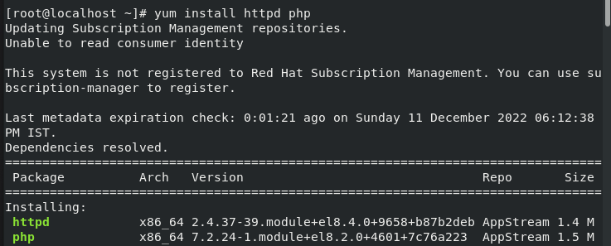

>>>> yum install gcc glibc glibc- comman

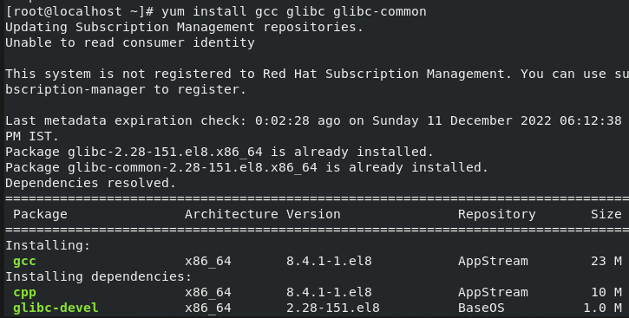

>>>> yum install gd gd-devel

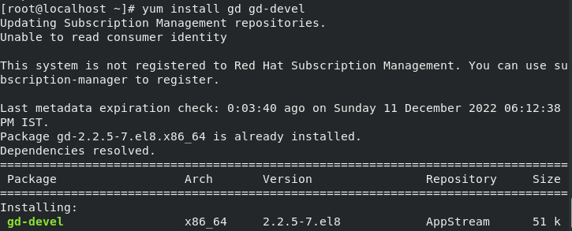

>>>> adduser -m nagios

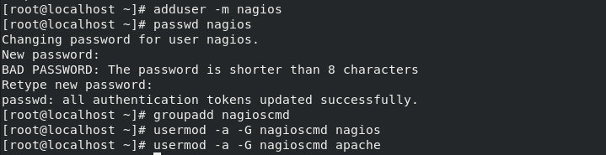

>>>> usermod -a -G nagioscmd apache



>>>> wget http: // prdownloads.sourceforge.net/sourceforge/nagios/nagios-4.0.8.tar.gz

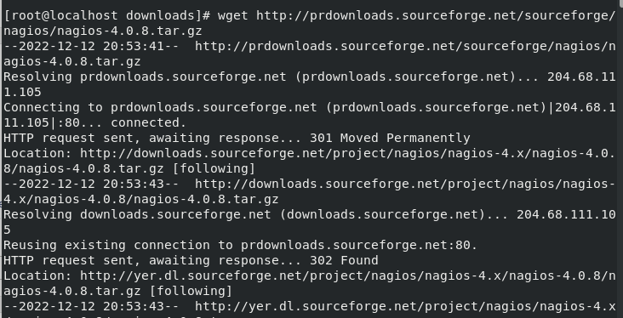

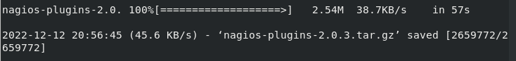

>>>> tar zxvf nagios -4.0.8.tar.gz

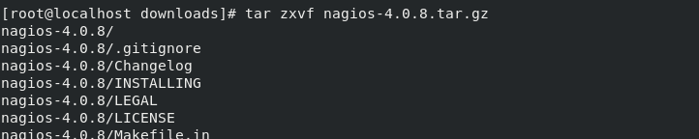

>>>> cd nagios - 4.0.8



>>>> ./configure – with - command-group = nagioscmd

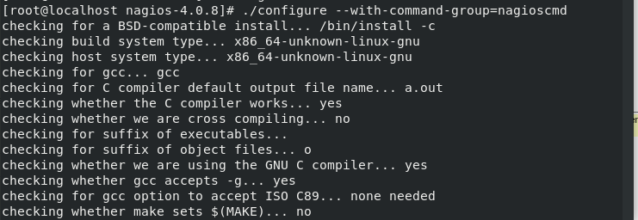

>>>> make all

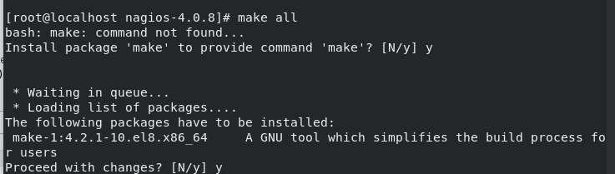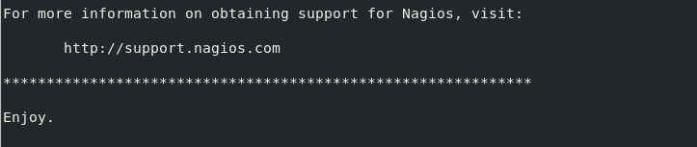

>>>> make install

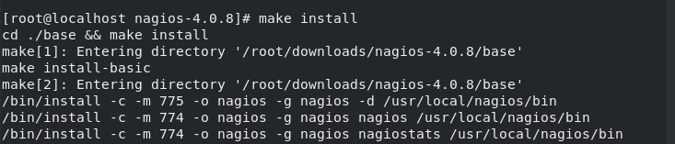

>>>> make install -config

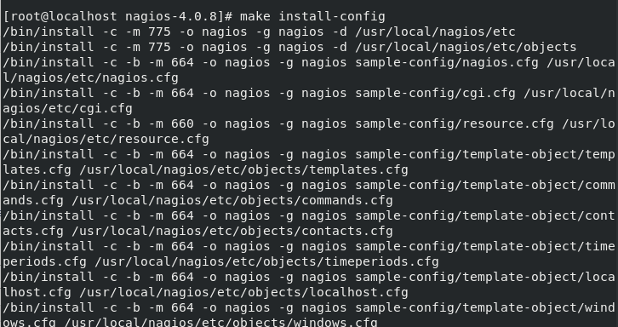

>>>> make install -commandmode

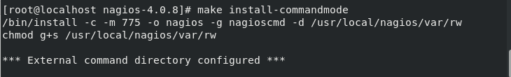

>>>> make install-webconf

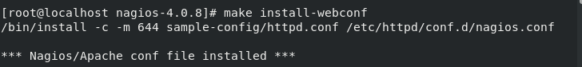

>>>> htpasswd -c /usr/local/nagios/etc/htpasswd.users

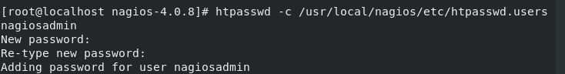

>>>> service httpd restart

>>>> restart httpd.service



>>>> cd

>>>> cd~/dounloads



>>>> tar zxvf nagios-plugins-2.0.3.tar.gz

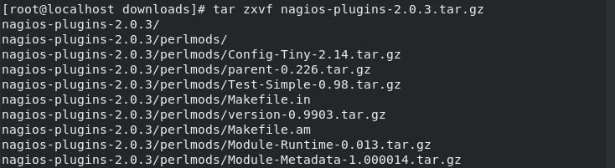

Cd nagios-plugins-2.0.3

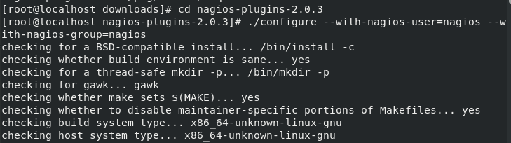

>>>> make

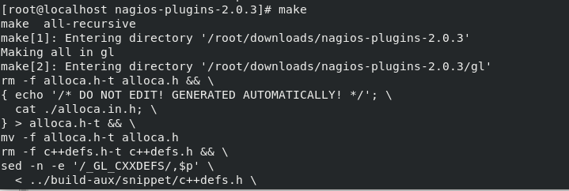

>>>> chkconfig –add nagios

>>>> chkconfig nagios on

>>>> /usr/local/nagios/bin/nagios -v /usr/local/nagios/etc/nagios.cfg

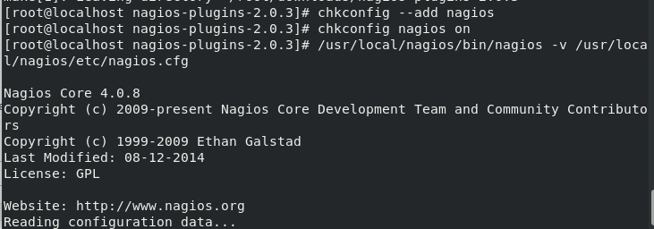

>>>> service nagios start

>>>> service httpd restart

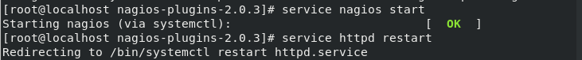

[root@localhost anurag]# cd /usr/local/nagios/etc/

[root@localhost etc]# ls

cgi.cfg htpasswd.users nagios.cfg~ resource.cfg

cgi.cfg~ nagios.cfg objects resource.cfg~

[root@localhost etc]# cd objects/

[root@localhost objects]# ls

commands.cfg localhost.cfg switch.cfg timeperiods.cfg

commands.cfg~ localhost.cfg~ switch.cfg~ timeperiods.cfg~

contacts.cfg printer.cfg templates.cfg windows.cfg

contacts.cfg~ printer.cfg~ templates.cfg~ windows.

[root@localhost objects]# vim localhost.cfg

define host {

use linux-server

host_name keen.example.com

alias sarathi

address 192.168.122.113

check_command check_tcp!80

}

# Define a service to "ping" the local machine

define service{

use local-service ; Name of service template to use

host_name keen.example.com

service_description PING

check_command check_ping!100.0,20%!500.0,60%

[root@localhost objects]# /usr/local/nagios/bin/nagios -v /usr/local/nagios/etc/nagios.cfg

Checking global event handlers...

Checking obsessive compulsive processor commands...

Checking misc settings...

Total Warnings: 0

Total Errors: 0

[root@localhost objects]# systemctl status nagios.service

● nagios.service - LSB: Starts and stops the Nagios monitoring server

Loaded: loaded (/etc/rc.d/init.d/nagios; generated)

Active: active (running) since Mon 2022-12-19 21:30:56 IST; 11s ago

Docs: man:systemd-sysv-generator(8)

Process: 3721 ExecStop=/etc/rc.d/init.d/nagios stop (code=exited, status=0/SU>

Process: 3732 ExecStart=/etc/rc.d/init.d/nagios start (code=exited, status=0/>

Tasks: 6 (limit: 8024)

[root@localhost objects]# service httpd restart

Redirecting to /bin/systemctl restart httpd.service

[root@localhost objects]#

Browser hit

ip/nagios/

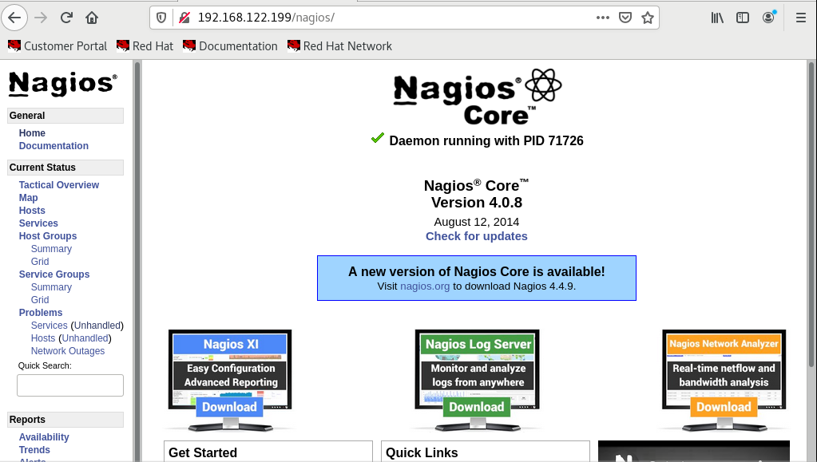

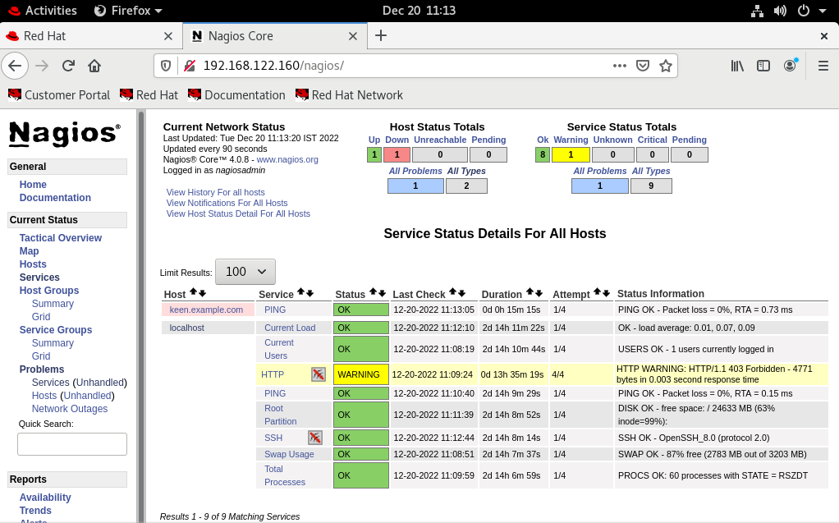

2nd

Vm create

Client vm and set nrpe

[root@keen sanu]# yum install -y nrpe nagios-plugins

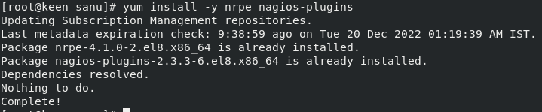

[root@keen sanu]# cd /etc/nagios/



[root@keen nagios]# ls

nrpe.cfg



Add ip address nrpe.cfg

allowed_hosts=127.0.0.1, 192.168.122.160



This script uncommented

command[check_init_service]=sudo /usr/lib64/nagios/plugins/check_init_service $ARG1$

command[check_services]=/usr/lib64/nagios/plugins/check_services -p $ARG1$

### SYSTEM UPDATES ###

command[check_yum]=/usr/lib64/nagios/plugins/check_yum

#command[check_apt]=/usr/lib64/nagios/plugins/check_apt

### PROCESSES ###

command[check_all_procs]=/usr/lib64/nagios/plugins/custom_check_procs

command[check_procs]=/usr/lib64/nagios/plugins/check_procs $ARG1$

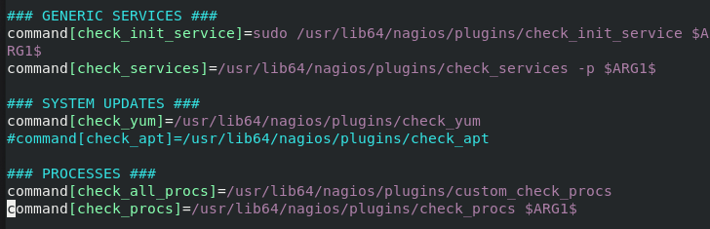

[root@keen ~]# systemctl status nrpe.service

● nrpe.service - Nagios Remote Plugin Executor

Loaded: loaded (/usr/lib/systemd/system/nrpe.service; enabled; vendor prese>

Active: active (running) since Tue 2022-12-20 12:34:31 IST; 20s ago

Docs: http://www.nagios.org/documentation

Process: 8572 ExecStopPost=/bin/rm -f /run/nrpe/nrpe.pid (code=exited, statu>

Main PID: 8576 (nrpe)

Tasks: 1 (limit: 8024)

Memory: 748.0K

CGroup: /system.slice/nrpe.service

└─8576 /usr/sbin/nrpe -c /etc/nagios/nrpe.cfg -f

firewall-cmd --list-all

systemctl restart firewall

firewall-cmd --permanent --add-port=5666/tcp

systemctl start firewalld

systemctl status firewalld

firewall-cmd --permanent --add-port=5666/tcp

firewall-cmd --permanent --add-port=5667/tcp

firewall-cmd --permanent --add-port=5668/tcp

firewall-cmd cmd --reload

firewall-cmd --reload

firewall-cmd --list-all

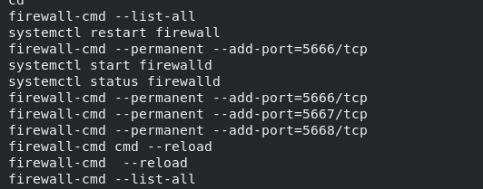

hostnamectl set-hostname keen.example.com



Output

NRPE set sucess



Prometheus target set

Nrpe port :-5666

jai@jai-base:~$ podman pod restart 595782e86955

595782e86955c9020a08823943be1411dcb9a95e09a40efee9c641d19f01775d

jai@jai-base:~$ podman pod restart 11bbd08817fe

11bbd08817fe48299c557ecc6c2deb62f7739f6927568bb5d3a8ce878c343751

jai@jai-base:~$ podman exec -it prom sh

/prometheus $ cd /etc/prometheus/

/etc/prometheus $ vi prometheus.yml

/etc/prometheus $

# A scrape configuration containing exactly one endpoint to scrape:

# Here it's Prometheus itself.

scrape_configs:

# The job name is added as a label `job=<job_name>` to any timeseries scraped

- job_name: "prometheus"

# metrics_path defaults to '/metrics'

# scheme defaults to 'http'.

static_configs:

- targets: ["localhost:9090"]

- targets: ["192.168.29.68:9187"]

- targets: ["192.168.29.68:5556"]

- targets: ["192.168.29.68:9999"]

- targets: ["192.168.29.68:9256"]

- targets: ["192.168.122.160:80"]

- targets: ["192.168.122.113:5666"]

Port down show

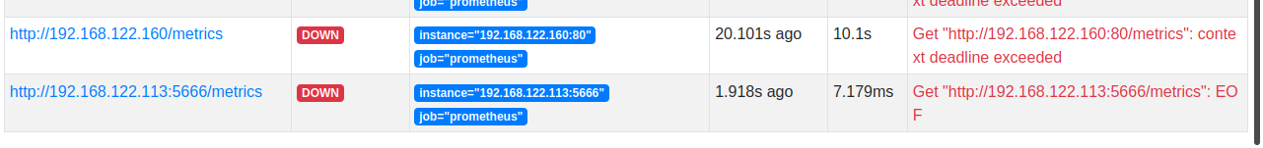

Work in process

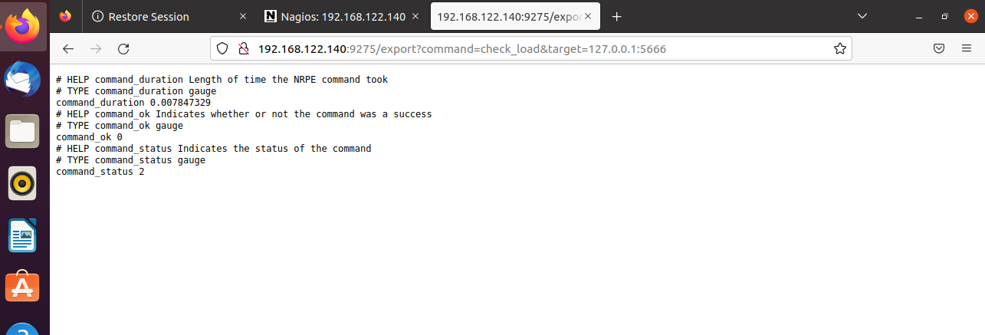

Grafana

container:-



